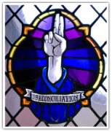 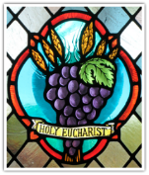

First Reconciliation & First Eucharist

Important Dates 2024

**January 9 (6:00PM) Parent Meeting; First Reconciliation books go home**

Sacramental preparation books are used to help share the preparation process with the parents and family. The purpose is to open up a dialogue between the students and parents in addition to the details addressed in the textbooks. *Family interaction is an important part of the preparation process.*

**January 17 (5:00-6:00PM) First Reconciliation Prep Class** *(date subject to change)*

The Prep Classes are intended to have share time with other students preparing and to be familiar with what OLPH community. Videos, share time, and tours of the church will be included in these Prep Classes. At least one adult is required to attend the class with the child.

**February 7 Vests go home**

For those new to OLPH, felt vests are made and distributed to the students. They decorate it with things that characterize them such as sports, music, reading, family, and especially religious symbols.

**February 21 Vests & Books come back** *(make sure name is in book)*

**February 27 (5:00PM) 1st Reconciliation Practice & First Eucharist Meeting**

The practice is required so the parents and students understand where everyone will need to go for the ceremony. Details about 1st Eucharist will be discussed.

**February 28 (6:30PM) 1st Reconciliation; First Eucharist books go home**

**March 6 (5:00-6:00PM) First Eucharist Prep Class** *(date subject to change)*

**April 27 (9:00-12:00) Retreat/rehearsal**

Parent volunteers are needed for the day for the different stations and

to bring students from station to station. A short rehearsal will be included.

**May 4 (10:00AM – Group Pictures begin at 9:15AM) First Eucharist Ceremony begins at 10:00 AM – All students**